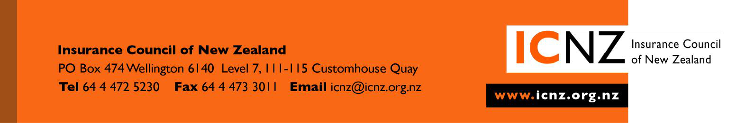

12 October 2012

Jo Elworthy
Committee Secretariat
Transport and Industrial Relations
Parliament Buildings
WELLINGTON

jo.elworthy@parliament.govt.nz

INSURANCE COUNCIL’S SUBMISSION TO THE MARITIME LEGISLATION BILL 2012 THAT PROPOSES TO MAKE A NUMBER OF CHANGES TO THE MARITIME TRANSPORT ACT 1994

The Insurance Council represents 27 insurers, 11 of which provide various forms of Marine Insurance such as Cargo, Hull and Liability. The content of the Maritime Legislation Bill is of interest to our members.

The Insurance Council is pleased to be able to express its support to the intent of the Maritime Legislation Bill 2012.

The Bill provides for access to more realistic levels of compensation from vessel owners whom may pollute New Zealand’s coastline. The Bill should provide better controls over certain Maritime activities that could threaten New Zealand’s unique marine and coastal environment and New Zealand’s economy.

- IMO Convention on Limitation of Liability for Marine Claims [LLMC] 1996

Its most important that New Zealand, being a signatory to this Convention that currently only has protection under the original liability limitation limits set under the LLMC 1977 now adopts the 1996 Protocol which effectively provides for double the liability claiming rights.

The Insurance Council agrees that there needs to be mechanism with in the Maritime Transport Act that will allow for adoption of any future higher limits that may become applicable under the LLMC Convention such as the most recent LLMC protocol that was developed for international adoption in April 2012 proving higher limits again.

The complexities of the practice distribution of any LLMC and Civil Liability for Bunker Oil Pollution Damage funds to parties needs to be set out and made clear with some specific court rules that would deal with the assessment and distribution of these funds. Article 10 of the LLMC provides for domestic law to provide some form of constitution of the claiming rights and use of any funds. It would appear that this is currently lacking in the Bill.
The Insurance Council recommends that these court rules need to be included in the bill.

- Regulation of alcohol consumption by seafarers

The Insurance Council supports this new provision. Alcohol abuse by seafarers directly impacts safety at sea risking loss of life, injuries, damage to property and the environment.

- Operation of a ship

The Insurance Council also supports the inclusion of offences and penalties for a ship not being operated safely. Vessels being operated unsafely directly impacts safety at sea risking loss of life, injuries, damage to property and the environment.

SUMMARY

The Insurance Council fully supports the intent of the Bill. We feel that provisions for up dating domestic law to allow for an effective framework for working through claims on any limitation fund needs to be included.

We would be happy to appear before the Select Committee to speak to our submission if required.

We can be contacted at:

John Lucas - Insurance Manager
(04) 495 8006 or john@icnz.org.nz.

John Lucas
Insurance Manager

