**CONSULTATION ON THE DRAFT REVISED GUIDE TO THE NATIONAL CIVIL DEFENCE EMERGENCY MANAGEMENT PLAN 2015**

From



To

Ministry of Civil Defence & Emergency Management

**8 September 2015**

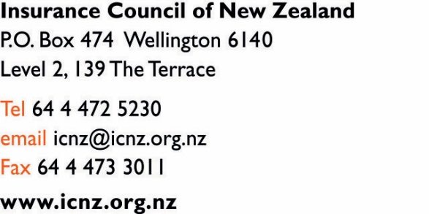

Posted to Ministry of Civil Defence & Emergency Management PO Box 5010 Wellington

Emailed to: [NationalCDEM.Plan@dpmc.govt.nz](mailto:NationalCDEM.Plan@dpmc.govt.nz)

**Draft Revised Guide to the National Civil Defence Emergency Management Plan 2015**

Thank you for the opportunity to submit on the draft revised guide to the National Civil Defence Emergency Management Plan 2015.

**About us and our interests in the Consultation Document**

1. ICNZ represents the interests of the fire and general insurance industry in New Zealand. Our 28 members insure over $600 billion worth of New Zealand assets and liabilities.
2. The Insurance Council’s members pay property damage claims that allow New Zealanders to recover from a Natural Disaster. As at the end of June 2015 Insurance Council members had paid over $15 billion in property claims for the rebuild of Canterbury.
3. The Insurance Council strongly supports the CDEM Plan’s focus on risk reduction that when implemented should reduce the impact of New Zealand to the effects of both natural and manmade disasters. This is timely as it is consistent New Zealand obligations under the Sendai Framework for Disaster Risk Reduction that the New Zealand Government has recently signed up to.

**ICNZ comments to the Draft Revised Guide to the National CDEM Plan 2015**

Attached is the submission form with a number of recommended revisions covering sections 15.5, 24.3 & appendix 3.

These revisions reflect (in order) the need for CDEM agencies:

1. The BCA to communicate relevant information about buildings and other property that are being considered for demolitions and partial demolitions to insurers. The Insurance Council has an internal process for communicating such information to its member insurers and can facilitate any dialogue required between BCAs, insurers and property owners.

This is important as in the Canterbury earthquakes some buildings were demolished needlessly and many buildings were demolished without insurer’s knowledge which created claim settlement issues later.

1. To communicate the relevant disaster event information not just to the lead agency, other responders and the public but also to insurers directly via the Insurance Council and EQC. It’s important that insurers and EQC are engaged with recovery agencies as this allows better coordination and more effective recovery.
2. The Insurance Council’s role in disasters is now better described in the new section in Appendix 3 as well as its focus on how to reduce both the social and economic impacts of natural hazards in New Zealand.

**Additional Comments on Section 17 – Reduction**

Section 17.4 “Legislation involving aspects of Reduction” (table 89 list of various legislation involving aspects of reduction)

ICNZ notes that inconsistencies exist across some of these pieces of legislation. They should be reviewed to ensure better alignment with the object of reducing risks.

ICNZ supports the transparency of natural hazard risk information being accessible to all New Zealanders so that New Zealanders make better informed choices on where they live and where they invest. We see this as a function of government to enable this to happen.

We trust that the Ministry of Civil Defence & Emergency Management will find our submission to the Draft Revised Guide to the National Civil Defence Emergency Management Plan 2015 clear and informative.

Should the Committee Secretariat have any questions then please contact either Chief Executive Tim Grafton [tim@icnz.org.nz](mailto:tim@icnz.org.nz) 04-495-8001) or Insurance Manager John Lucas [john@icnz.org.nz](mailto:john@icnz.org.nz)

(04 495 8006).

Yours sincerely,

 

**Tim Grafton John Lucas**

Chief Executive Insurance Manager