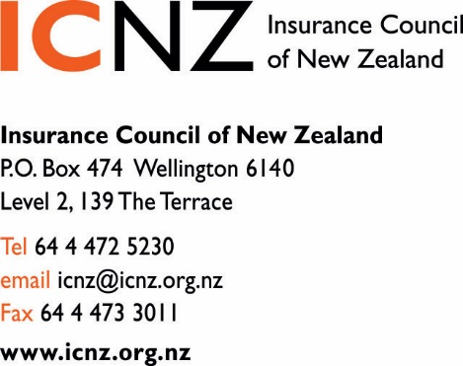

26 November 2015

Ministry of Business Innovation & Employment
PO Box 1473, Wellington 6140

revisionbill@mbie.govt.nz

SUBMISSION OF THE INSURANCE COUNCIL OF NEW ZEALAND
CONTRACT and COMMERCIAL LAW BILL

- The Insurance Council of New Zealand (ICNZ) represents the interests of New Zealand’s general insurers, that is, we do not represent Life or Health insurers. Our members write cover that protects about $600 billion of New Zealand’s assets including house, contents, motor, commercial, marine, liability, travel and other insurance lines.

- ICNZ is pleased to provide its submission to the Contract and Commercial Law Bill and supports the intent of the bill that will aim to see a number pieces of legislation that are fairly old but very import for commerce in New Zealand made more accessible, readable and easier to understand.

- The ICNZ’s submission will focus on the Carriage of Goods Act 1979 (CoGA). CoGA sets an important legislative frame work governing the liability for carriers and transport generally. Our members provide both carriers liability insurance and marine cargo insurance.

- Many of the terms contained in the CoGA are maritime terms that are commonly used in shipping and insurance legislation that is well understood by the maritime law fraternity and the insurance industry. Changing some of these terms could risk misaligning the CoGA with other related law such as the Marine Insurance Act 1908 and insurance contracts.

The Proposed Changes

- Section 245 Meaning unit of goods.
The proposal to delete the reference to “unit of bulk” could create a less clear and less specific definition risk. Bulk or bulk cargo is the maritime definition of commodity cargo that is transported unpackaged in large quantities. It could be liquid like petroleum or a dry solid like coal or gravel. Bulk could be determined to be different from weight. Bulk is more related to volume of a commodity in a ship or on a truck. ICNZ strongly recommends that the current definition for “meaning of unit of goods” should be left unchanged.

- Section 247 Particular kind of contract is a matter for agreement subject to meeting requirements for that kind.
The exposure draft asks for feedback on the intention of the parties contracting out of “Limited Carriers Risk” being dependant on the correct contract label being used on the packaging. If a label is used, but conflicts with the terms of the actual agreement then it is our recommendation that the use of the correct label is not absolutely necessary and the original intention of the parties to contract out of the “Limited Carriers Risk” would take precedent.

- Section 262 Carrier not liable in certain circumstances “inherent vice” or “inherent defect”
We strongly disagree that “inherent vice” should be replaced with “inherent defect in, or the nature of, the goods” in the Bill.
“Inherent vice” is part of insurers’ and carriers’ vernacular globally. Courts have clarified and refined its meaning over a long period of time. It appears in numerous other domestic and international sources of law. It is standard to contracts of insurance and contracts for carriage of goods. It appears in the Marine Insurance Act 1908 in New Zealand, and the Institute Cargo Clauses, which are the foundation of most marine insurance cargo policies globally. Replacing “inherent vice” with “inherent defect” in the Carriage of Goods Act would therefore leave the Act at odds with law and practice domestically and globally.
In our view the replacement phrase is narrower than “inherent vice”. It is a fundamental change in the law and therefore outside the scope of what the Bill may do. We believe the replacement phrase is narrower because of the limitation to inherent defects in (or nature of) the goods, and the use of the word “defect”.
In decided cases, “inherent vice” has been interpreted to include vices external to the goods carried. Examples include loss caused by inadequate packing, loading, cracking, mildew and spontaneous combustion. Inherent vice can also include losses like ordinary leakage and breakage due to the natural behaviour of the goods during the ordinary course of transit, where there is no “defect” in the goods. “Inherent defect” is a narrower phrase and focuses on imperfections or inadequacies in the goods, thereby excluding external vices and other losses that occur where some pre-existing defect in the goods is not identifiable.
With the proposed amendment, carriers may become liable for these risks.
Overall, we support certainty and stability in the law. Given the universality of the phrase “inherent vice” and the significant potential for unintended consequences through differences in interpretation outlined above, we strongly disagree with the proposed change.

- We do trust that you will find our submission useful when reviewing the CoGA in terms of its readability and being a bit more modern in its structure and format.

- ICNZ does not intend to comment on the other 10 statutes that are subject to this review as we have not identifying them as having any negative effect on Insurance.

- If you encounter any questions then please do not hesitate to contact John Lucas on 04 495 8006 john@icnz.org.nz.

Yours sincerely

Tim Grafton John Lucas
Chief Executive Insurance Manager

See Chapter 18.8.4(2) of Colinvaux’s Law of Insurance in New Zealand (2014) at page 1245 for more information and case references. Also see Global Process Systems Inc v Syarikat Takaful Malaysia Berhad (The Cendor Mopu [2011] UKSC 5, which provides the most recent significant clarification of inherent vice in the common law world.

